Project title: Detecting Systemic Risk Buildup via Interbank Lending Network Analysis

Name: Lakshay Rajput
Student ID: 24070065
Programme: MSC Data Science
Module code: UFCF9Y-60-M

Abstract
Complex patterns of interconnectedness that are not represented well by traditional institution-level risk measures lead to systemic risk in interbank systems. This dissertation formulates an artefact-based analytical framework to study systemic risk in interbank settlement networks with data science, network analysis, machine learning, and visual analytics approach. The research employs a publicly available interbank settlement proxy data because the real interbank lending data are limited in availability, and this data maintains structural features needed in the network-based analysis.

The relationships between the banks are represented by directed and weighted networks, which make it possible to calculate network-based systemic risk indicators. Several centrality measures are examined and a composite systemic risk index is constructed to help overcome the shortcomings of the individual measures. A contagion simulation module (to estimate vulnerability to stress) is carried out, which measures the spread of failures based on exposure-based threshold guidelines. Moreover, network-derived features are subjected to unsupervised machine learning model to profile structurally anomalous institutions which can be given more attention. A set of visual analytics is created to make the interpreting process improved and facilitate the exploratory decision-making.

The findings reveal a distinct structural concentration of systemness where a small part of the institutions has disproportionate thru the network. The simulated contagion shows minimal spreading of the failures indicating that the settlement network under analysis is structurally resilient. The results of machine learning are correlated with the findings of the network, which proves the usefulness of a combined method of analysis.

In general, the research shows that network analysis, used together with simulation, machine learning, and visual analytics, can offer a consistent and understandable model of exploratory systemic risk analysis that can be applicable in risk monitoring and methodological studies but not in predicting real-world crisis.

Table of Contents
Abstract 2
Chapter 1: Introduction 5
1.1 Background and Context 5
1.2 Problem Definition 5
1.3 Aim, Objectives and Research Question 6
1.4 Scope and Assumptions 7
1.5 Structure of the Dissertation 8
Chapter 2: Literature Review 9
2.1 Systemic Risk and Financial Crises 9
2.2 Interbank Lending Networks 10
2.3 Network Metrics for Systemic Risk 11
2.4 Contagion and Failure Propagation Models 12
2.5 Research Gap and Positioning 12
Chapter 3: Methodology and Data Design 14
3.1 Research Design and Approach 14
3.2 Dataset Selection and Data Characteristics 14
3.3 Network Construction and Feature Engineering Methodology 15
3.4 Simulation and Machine Learning Methodology 15
3.5 Tools, Technologies, and Ethical Considerations 16
Chapter 4: Artefact Design and Implementation 17
4.1 Artefact Overview and Architecture 17
4.2 Data Pipeline and Preprocessing Implementation 17
4.3 Network Modelling and Systemic Risk Metric Implementation 18
4.4 Contagion Simulation and Stress Testing Module 18
4.5 Visual Analytics and Decision-Support Design 19
Chapter 5: Evaluation and Results 20
5.1 Evaluation Framework and Criteria 20
5.2 Network Structure and Systemic Risk Indicators 20
5.3 Contagion Simulation and Stress Scenario Results 21
5.4 Visual Analytics and Decision-Support Evaluation 23
Chapter 6: Discussion and Reflection 26
6.1 Interpretation of Findings and Link to Literature 26
6.2 Strengths and Limitations of the Approach 26
6.3 Personal and Technical Reflection 27
Chapter 7: Conclusion and Future Work 28
7.1 Summary of the Project 28
7.2 Achievement of Objectives 28
7.3 Future Extensions 28
References 29
Appendix……………………………………………………………………………………..30

Chapter 1: Introduction

1.1 Background and Context
The financial crises have proved on numerous occasions that the stability of the banking system cannot be well comprehended when one analyses the individual institutions separately. The global financial crisis that happened in 2008 showed that even banks that would seem to be financially sound and well capitalised at an individual level would be weak because of their widespread interconnection with other financial organisations (Duffie, 2019). These interdependencies allowed financial distress to spread very quickly through the system and changes in solitary failures into systemic wide crises. Consequently, the element of systemic risk has taken center stage in the contemporary researches on financial stability (Klinčić et al., 2023).
The conventional methods of evaluating financial risks have mostly been concentrated on the bank level data like capital adequacy ratios, leverage, liquidity coverage and credit exposure. Although these measures are still significant, they do not frequently include structural relationships between institutions that may increase shocks. Specifically, the balance sheet-based measures fail to capture the effect of indirect exposures that occur as a consequence of interbank lending where an event of failure of an institution may have cascading effects on the solvency of others. This shortcoming has elicited the growing interest in system-level analytical methods (Bardoscia et al., 2019).
The interbank lending markets are important in ensuring the liquidity and ensuring the smooth running of the financial system. Simultaneously, they establish intricate systems of commitments, which may serve as the transmission lines of contagion when it comes to times of stress. Interbank market Network-based models of interbank markets can explicitly model these interdependences and thus enable researchers to study the dynamics of risk accumulation and spread through the system (Macchiati et al., 2021). The network analysis of banks as nodes and lending relationships as edges is an effective way to find the structure of important institutions and the possible spots of weakness in the financial system.

1.2 Problem Definition
Even with the progress in the sphere of financial regulation and risk management, it is a challenge to recognize the accumulation of systemic risk. The nature of systemic risk is challenging to observe due to the fact that it arises due to the interactions among the institutions and is not related to the specifics of an individual bank. The risk may build up over time in the structure of the financial network, and it is a major invisible risk until there is a triggering event to bring instability broadly (Jiang et al., 2023).
Interconnectedness, although crucial in the sharing of liquidity and diversification of risks, may also cause hidden weakness. Institutions that have a high level of relatedness can serve as centres that end up relaying shocks throughout the system and thick concentrations of interbank exposures can be used to enhance the losses due to the feedback effects. Conventional monitoring systems usually lack a solution to these vulnerabilities could be detected early enough since they are not readily evident in conventional financial indicators (Cont and Schaanning, 2019).
The systematic issue that this project seeks to respond to is thus that there are no effective, system-level tools that can provide an early warning of systemic risk that is brought about by interbank connectivity. In particular, analytical methods are required to reflect the dynamic structure of interbank networks, measure systemic significance in relation to individual balance sheets, and assess the possibility of contagion during stressful situations (Roncoroni et al., 2019). This issue is crucial to improving the financial stability monitoring and developing a better insight into the processes behind the crisis creation in the interconnected banking systems.

1.3 Aim, Objectives and Research Question
Project Aim
The main aim of the study is to use data science and network analytics to identify and track systemic financial risk accumulation in interbank lending networks. The study also aims at identifying structural vulnerabilities of the financial system, tracing the paths of contagion, and giving warning signals of possible financial crises by modelling the financial system as a complex network of interconnected banks.
Project Objectives
To achieve this aim, the project pursues the following objectives:
- To choose and process an interbank settlement proxy dataset available in the public, which can be used in analyzing systemic risk in a network-based system.
- To model time varying, directed, and weighted networks of interbank lending relationship to capture change in systemic structure with time.
- To calculate interbank network features (centrality and structural vulnerability measures) based on network of interbank relationships to be used in systemic risk analysis.
- To utilize machine learning algorithms on these features derived on the network to identify trends, deviations, and advance warning signs related to accumulating systemic risk.
- To create interactive visualisations and dashboards which combine outputs of machine learning and network metrics that can be used to interpret and track systemic risk over time.
Research Questions
The research questions that will guide this study are as follows:
RQ1: What is the way to model interbank lending relationships as dynamic networks that can capture the change in systemic risk over time?
RQ2: Which measures of networks are best to determine systemically important institutions in interbank networks?
RQ3: How well can simulations of contagion highlight latent weaknesses and routes of propagation of failure in interconnected banking systems?
RQ4: How can systemic risk indicators be interpreted and made practically useful with the help of integrated visual analytics?

1.4 Scope and Assumptions
The specific project of interest is systemic risk that occurs due to interbank lending between financial institutions. Since the actual data of interbank transactions is confidential, the analysis is done on the data that dataset available publicly on kaggle. The data is aimed to recapitulate empirically measured properties of real world interbank markets, such as heavy-tailed distributions of exposures, sparse connectivity, and core-periphery network structure. This method allows experimentation to be controlled and analysis to be repeated and ethical and legal considerations to be upheld.
The research is also restricted to the wholesale interbank lending and does not include any retail banking activities, consumer credit risk, and optimisation of individual bank balance sheets. The analysis also does not cover macroeconomic factors, regulatory interventions as well as behavioural responses by financial institutions. A number of simplifying assumptions are made such as that behavioural rules remain constant throughout stress events and that contagion simulations follow a threshold. Such assumptions are required to make this analytically tractable and feasible within the context of a research project at the level of a masters.

1.5 Structure of the Dissertation
This dissertation is divided into seven chapters. Chapter 1 provides the context of the research, definition of the problem, aims, objectives and research questions of the research. Chapter 2 provides a critical analysis of the available literature concerning systemic risk, interbank lending networks as well as financial contagion such that critical gaps are identified to be motivating the proposed research. Chapter 3 describes the strategy of the research, such as data collection, network construction, the tools used, and ethical issues. Chapter 4 provides an account of the analytical artefact design and implementation, including data pipeline, network metrics, contagion sim framework and visualisation elements. Chapter 5 reviews the artefact and shares the results of the network analysis and simulating experiments in an empirical way. This chapter 6 talks about the results, comments on the strengths and weaknesses of the methodology, and reflects on what he or she has learned personally. Lastly, Chapter 7 completes the dissertation and provides what the future research may need to do.

Chapter 2: Literature Review

2.1 Systemic Risk and Financial Crises
The risk of the failure or distress of a single or more financial institutions causing systemic instability that impedes the operation of the whole financial system is commonly referred to as systemic risk. This is unlike idiosyncratic risk, which is specific to individual entities, because systemic risk arises due to interdependencies, feedbacks and non-linear interactions between institutions. This difference is imperative, because conventional risk management structures put much emphasis on solvency and liquidity of companies on a firm-by-firm basis, with little perspective on the vulnerabilities within the system as a whole (Castellano, 2024; Aufiero et al., 2025).
History has demonstrated what has been undone in these traditional methods through the previous financial crises. The 2008 world financial crisis proved the fact that systemic collapse can be caused by seemingly sound institutions, as shown by balance-sheet metrics, as argued by Brunetti et al. (2019) and Petrovska (2019) but by dense interbank exposures and correlated behaviours. The crisis response in terms of regulation has increased the capital and liquidity standards, however, the series of reactions that followed the crisis have indicated that structural interconnectedness remains as a latent risk (Brunetti et al., 2019; Petrovska, 2019). These events indicate that the systemic risk is not just a leverage or asset quality dependent issue but it is inherent in financial network structure.
The idea of too interconnected to fail builds upon previous ideas of too big to fail to the extent of relational significance instead of just size. Institutions with high interconnection can be the main nodes whose troubles can spread quickly to the interbank markets and strengthen shocks despite the fact that their respective balance sheets may seem to be strong. As pointed out by Jackson and Pernoud (2020) and Berner, Cecchetti and Schoenholtz (2022), Nevertheless, the notion also comes with challenges of analysis, whereby interconnectedness may contribute to both liquidity provision and risk sharing at the same time in normal circumstances (Jackson and Pernoud, 2020; Berner, Cecchetti and Schoenholtz, 2022). This duality makes regulation evaluation more difficult and highlights the necessity of analytical paradigms that can separate the two types of network structure, stabilising and destabilising. As a result, network perspectives have increasingly been brought to the fore of modern systemic risk studies.

2.2 Interbank Lending Networks
Interbank lending networks can be used as a natural means to model financial systems as assemblies of interrelated institutions as opposed to lone institutions. Banking networks The banks are represented as nodes and lending relations as directed and weighted edges that reflect both the direction and intensity of the financial exposures (Jackson and Pernoud, 2020; Leventides et al., 2023). The advantages of this network-based view are that researchers get to examine the way in which liquidity, risk, and shocks spread through the system, which cannot be done by either doing an aggregate or institution-level analysis. As demonstrated by Denbee et al. (2021) and Ferracci and Cimini (2021), interbank networks can be used to identify structural aspects that can either contribute to or reduce systemic risk because interdependencies are explicitly modelled (Denbee et al., 2021; Ferracci and Cimini, 2021).
One of the stable results of empirical findings in the literature on interbank markets is the existence of core periphery structures. At such structures, a relatively few highly connected core banks will take part in intense mutual lending, with a larger periphery of less connected institutions mainly being involved with core banks as opposed to among themselves. This arrangement has been seen in several jurisdictions and periods of time and is commonly seen to be an effective way of distributing liquidity in a normal market environment (Garcia Pascual et al., 2025). Nonetheless, the very structure is also the cause of weakness when the core gets stressed, where distress can easily spread to the periphery because it has a concentrated exposure pathway.
Empirical studies on interbank networks have also shown that these networks are not static. Network density, centrality distributions and clustering patterns change over time based on market conditions, change in regulations and liquidity constraints. It has been demonstrated that betweenness and eigenvector centrality measures can rise steeply in specific institutions before financial stress periods, and are thus becoming more systemically relevant (Alexandre et al., 2021; Markose et al., 2021). However, empirical evidence also points at an important heterogeneity between markets and time horizons, and indicates that no single network measure can entirely explain systemic vulnerability. These observations can justify the necessity of dynamical multi-metric models, which take into consideration both the structural and the temporal aspects of interbank lending networks in measuring systemic risk (Abduraimova and Nahai-Williamson, 2021; Li, Fu and Li, 2025).

2.3 Network Metrics for Systemic Risk
Network measures are key in the measurement of systemic risk by converting the systemic characteristics of the interbank lending networks into quantifiable measures of susceptibility and impact. Centrality measures are among the most commonly used ones and they are designed to determine institutions that have a structural significance in the network. The degree-based centrality measures the degree of links that a bank has and this provides an easy measure of the degree of involvement in interbank markets (Mahdavi Ardekani, Distinguin and Tarazi, 2019; Aref Mahdavi Ardekani, Distinguin and Tarazi, 2020). More sophisticated metrics, like betweenness centrality, determine how far a bank is placed on the shortest paths between other banks, therefore, pointing to possible pathways in which financial distress can spread. As evidenced by Coen and Coen (2019), eigenvector-based measures also take into consideration the value of counterparties of a bank in that it is known that relationships with very powerful institutions can increase systemic effects (Coen and Coen, 2019).
In addition to the concept of centrality, there are other approaches to network fragility and these include clustering and k-core decomposition. The clustering coefficient is a measure of how much banks are concentrated in closely-knit groups, which can make sharing of liquidity easier, however, provide easy spread of contagion during stress. The high clustering can thus suggest that there is localised resilience in the times of stability and more vulnerability in times of crisis. As documented by Artime et al. (2024) and Diallo and Hecking (2024), K-core analysis: Identifies closed networks of sub-networks with strong connections, by repeatedly executing the activity of disconnectedly reassuring the nodes, which allows identifying the core of a network which is perhaps central to the overall stability (Artime et al., 2024; Diallo and Hecking, 2024). Systemic importance Banks in the higher-order cores are typically regarded to be systemically important because they are rooted so deep into the network structure.
Although, on their own, the individual network measures are valuable, they have significant limitations. The measures of centrality may be sensitive to the size of the network, its density and aggregation of the data and this can minimize comparability over time or systems. Clustering and k-core measures offer structural information, but not the size of the financial exposures or stress behaviour responses. Furthermore, alternative measures can also deliver conflicting systems importance rankings which act as a hurdle in the interpretation of their results when applied in risk monitoring (Gandica, Béreau and Gnabo, 2020; Brogi, Lagasio and Riccetti, 2021). These shortcomings indicate that no single indicator can be sufficient to measure systemic risk and as such, it is desirable to have multiple metrics of a network combined into composite measures, which better represent systemic vulnerability.

2.4 Contagion and Failure Propagation Models
Financial contagion is the mechanism by which the distress in one institution is transmitted to others, and may ultimately cause instability throughout a system. Direct credit exposures and liquidity shortages, along with feedback effects as a result of interconnected balance sheets, are the major causes of contagion in interbank markets. By defaulting a borrowing institution, its lenders might suffer losses which undermine their financial standing making them more prone to other failures. As argued by Acemoglu et al. (2020) and Aufiero et al. (2025), these processes point to the manner in which local shocks can lead to systems events in networked interactions (Acemoglu et al., 2020; Aufiero et al., 2025).
Stress testing and cascade models have gained popularity in systemic risk studies in order to analyse such dynamics. The stress testing models generally subject the financial system to exogenous shocks, (e.g. the collapse of a major institution or a prompt fall in asset prices) and assess the influence on the financial system. Cascade models are based on this methodology but propagation of endogenous failures is simulated such that secondary default is a result of accumulated losses that surpass predetermined limits. Although these models contain useful information on possible ways of contagion, they can be based on simplifying assumptions concerning the behaviour of banks, recovery rates, and stability of networks. Consequently, their products must be viewed as indicative and not as predictive (Tabachová et al., 2023; Fukker and Kok, 2024). Contagion models and cascade models are, however, necessary in the study of the vulnerability of the interconnected banking systems in the adverse environments.

2.5 Research Gap and Positioning
Despite the considerable progress in the current research in terms of understanding the systemic risk, most of the methods analyze the problem in its parts separately. Network-based analyses tend to concentrate on a snapshot of the network or individual centrality measures or hypothetical contagion mechanisms without taking time dependence of risk into account. Equally, stress testing models are often not coupled with fine-grained network structures or do not incorporate visual aids, which enhance the model readability.
This project places itself by solving these shortcomings using a dynamic holistic approach. Instead of using one metric or a fixed representation, the study incorporates time-varying network analysis, many systemic risk indicators, and failure propagation simulations as one analytical artefact. Given the interactive visual analytics as a complement to quantitative findings, the project will be used to increase analytical insight as well as practical utility. It is a stance that makes the cumulative risk in interbank lending networks systemic by providing a more holistic approach to existing literature by way of integration and not the creation of totally new theoretical frameworks.

Chapter 3: Methodology and Data Design

3.1 Research Design and Approach
The study is grounded in a quantitative and data-based study design that addresses the issue of systemic risk in interbank settlement networks (Alexandre et al., 2021). It is simulation based with analytical approach where structural behaviour and risks dynamics are of interest as opposed to forecasting possible financial crisis in the real world. This is appropriate given the fact that interbank markets are very complex and confidential.
The artefact-based methodology develops a systematic of analysis based on network analysis, contagion modeling, machine learning, and visual analytics. The network that is based on interbank relationships is directed, and weighted, which allows analyzing interconnectedness, systemic importance, and propagation of failures (Md Masud Kowsar, Mohiuddin and Islam, 2023).
The technical nature of systemic risk is non-linear and relational, and is far more complex than institution level controls. Network and machine learning provide a holistic picture of the dependency and anomalies (Pacelli, 2024).
The criterion of the study is not prediction but analytical clarity and interpretability aimed at providing opportunity to take early warning and identify risks.

3.2 Dataset Selection and Data Characteristics
Authentic interbank lending and settlement statistics are very secret, where only a couple of people have access to them due to the financial stability sensitivity and regulation by central banks. Bilateral exposures at an institution are not openly announced, since such exposures might create systemic exposures or negative response in the market place. Therefore, a methodology on empirical studies is commonly based on simulated data or proxy data (Sharafutdinova and Lokshin, 2021).
In this study, the authors took the 6G Interbank Settlement Data on Kaggle, which is a proxy of an interbank system, to represent an interbank transaction network (Ziya, 2025). The dataset will record transactions settlements between financial bodies, including sending and receiving institutions as well as the amount of the transaction. It is comprehensive, clean and none of the values are missing so that analysis is complete and can be replicated (Bonato, Palan and Szava, 2025; Bonato, Sebastian and Szava, 2024).
Although the data is simulated, it has certain structural properties similar to those that are important in interbank network databases: directional flows, weighted values, and nonlinear connectivity. They allow one to construct directed, weighted graphs with stylized facts of real interbank systems. It is artificial but facilitates an exploration of methodology without necessarily making predictions and correlations to the real world (Guleva, 2020; Honvehlmann, 2024).

3.3 Network Construction and Feature Engineering Methodology
The proposed study applies an interbank settlement network theory, directed and weighted thus using the nodes as the financial institutions (banks) and directed edges as settlement flows between sending and receiving institutions. The transaction volumes are captured in edge weights, which is used as a proxy of financial exposure. This method is appropriate in the directional and different magnitudes of interbank transactions which is important in measuring systemic importance (Roncoroni et al., 2021).
Network construction Purging and normalizing of transaction data to be able to consistently identify their institution, deleting self-loops (e.g. a bank transacting with itself) to eliminate useless relationships, and converting clean data into an edge-list format to create network objects.
Systemic relevance can be quantified through network features that are engineered in this way; in-degree and out-degree centrality (exposure absorption and transmission), betweenness and eigenvector centrality (brokerage and influence). Normalized measures are added together to come up with a composite systemic risk score (Cao, Wen and Eugene Stanley, 2021; Deng, Zhang and Zhu, 2021).
The feature engineering is also necessary when implementing machine learning models since they cannot reject raw data, but rather a structured input since they have structured network-driven outputs that can directly answer RQ2 by identifying systemically important institutions, including the position of the institutions in a network.

3.4 Simulation and Machine Learning Methodology
The model impersonates the contagion and propagation of failures in the interbank network to determine the systemic vulnerability to stress. Scenarios are triggered by exogenous failures of a few systemically important institutions-which are identified through network based risk measures. The model has propagated distress with incoming exposure ties and additional losses on threshold-proportional loss absorption. The most important outcome measure is the cascade size, which is the number of failed institutions after the shock (Grassia, De Domenico and Mangioni, 2021).
Also, machine learning through the Isolation Forest algorithm does offer early notifications, since there are no ground-truth crisis labels in interbank data. It is an unsupervised algorithm that identifies abnormalities in institutions within the network of which the characteristics are above the mean, where the inputs are centrality metrics and the systemic risk (Balmaseda, Coronado and Cadenas-Santiago, 2023).
Network analysis Network analysis is complementary, not replacementary, by machine learning: It receives various structurally suspicious institutions to be monitored more closely, not as a black-box predictor.

3.5 Tools, Technologies, and Ethical Considerations
The analysis artifact presented in this study is written in Python, the programming language selected due to good data science and machine learning package collections (Zheng, 2024). The entire analysis is done in Google Colab in case of reproducibility in clouds and similar environments. Pandas and NumPy are used to do core data processing; directed and weighted interbank networks are developed and categorized using NetworkX. Scikit-learn provides the implementation of ML models, matplotlib is used to generate visualizations, and outputs can be received in the form of optional Power BI with suit dashboards (Herzen et al., 2022).
It is ethical that employs only public and non-sensitive data, no real organizations and PII. They are confidentialized by anonymizing all of them. All the ethical risks can be reduced because transparent documentation and deterministic modelling guarantee reproducibility.

Chapter 4: Artefact Design and Implementation

4.1 Artefact Overview and Architecture
In this paper, the artefact of the analysis system is provided to investigate systemic risk on interbank settlement networks. It is a combination of interrelated components that can offer both an exploratory and diagnostic analysis through a modular pipeline. It starts with data ingestion - settlement data which is transaction-led, loading, and validating transaction-derived graphical models and network construction, interbank relationships (Capozzi et al., 2025; Khanvilkar and Kommuru, 2025).
The following modules are the computation of systemic risk metric, the structure significant measures based on networks, and contagion simulation on stress propagation. Structurally abnormal institutions are identified by a machine learning layer, which works together with network insights. The visual analytics promote interpretation and the decision-making. Theoretical design not operational (Zlata Tabachová et al., 2023).

4.2 Data Pipeline and Preprocessing Implementation
The artifact starts with the consumption of publicly available Kaggle dataset data into the processing environment. Primary validation checks Data type and structure schema, and makes sure that there are no missing or incomplete values, which forms a solid basis of analysis (Akella et al., 2025; Bou-Ammar et al., 2025).
Data cleaning is associated with specific cleaning processes (Lazcano and Jaramillo-Moran, 2025). Institutions are identified in a normalized way to ensure consistency, self-loops are eliminated which have no interbank meaning and transactions are represented in edge-list format that contains a directed relationship with a value.
This edge-list option facilitates the efficient network building as well as the network examination using library of graphs, thereby maximizing reproducibility and scalability of their individual analyses. These procedures will make sure that the downstream networkor simulation analysis is based upon consistency and interpretable data. 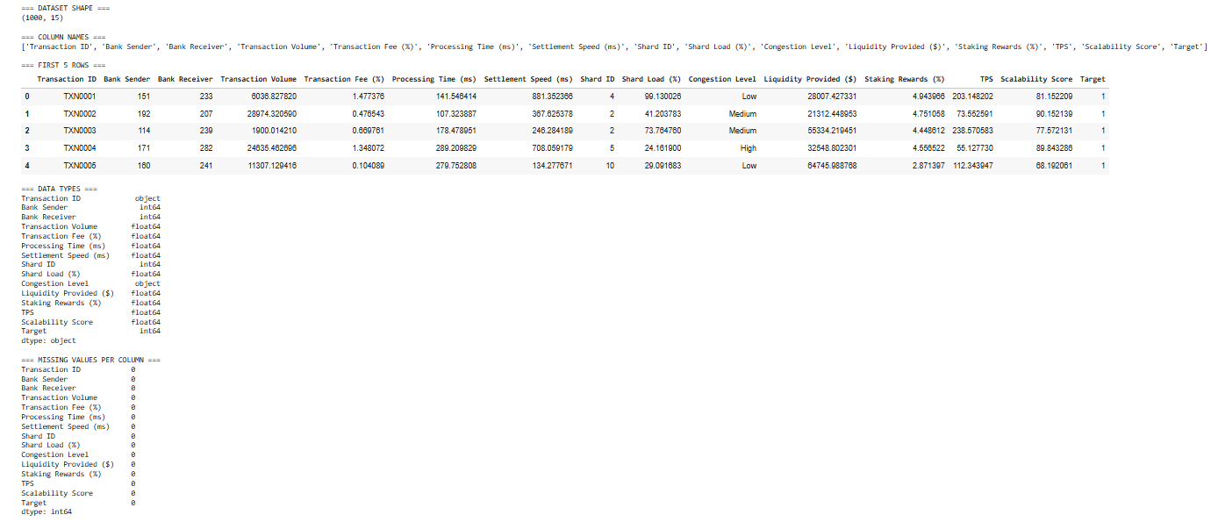

4.3 Network Modelling and Systemic Risk Metric Implementation
Interbank settlements in interbank financial networks, the nodes represent financial institutions, directed, which denote outbound to inbound networks and the weightings indicate the weight. Directional nature of the transactions and dissimilar exposures underlying the systemic risk analysis are expressed through the edge weights of the transaction as the proxy of financial exposure (Nowaczyk and O’Halloran, 2024).
Network centrality metrics are measures of institutional relevance across structures: in-degree and out-degree centrality are measures of exposure absorption/transmission; betweenness centrality is a measurement of shortest path brokerage; eigenvector centrality measures connectivity to central nodes (Clapham et al., 2021).
Empirically, betweenness and eigenvector centralities are not discriminating on a sparse network, which indicates the vulnerability of individual measures to systemic significance. Normalized and equally weighted centralities give a composite index, which makes robust and relative rankings, but not predictions and incorporates more systemic dimensions that provide more resilience (Huang et al., 2024).

4.4 Contagion Simulation and Stress Testing Module
The artefact consists of contagion and stress testing simulator of the interbank network to determine systemic weaknesses. It provokes situations through failures of systemically important institutions as determined by the composite systemic risk index-they are exogenous shocks rather than financial distress (Roncoroni et al., 2021).
The model of propagation of failure is based on incoming exposure, and the losses are proportional to transaction with failed counterparties. The failures that follow are when the losses hit a set exposure limit through simplified threshold rules of analyzing scenario instead of behavioral modelling (Markose et al., 2021).
The outputs this takes the form of failed institutions and cascade size which measures the spread of shock. There was no secondary contagion after the initial failures, and this is the indication that it was structurally strong. Simulations do not portray real life predictions, but hypothetical stress of a network (Smolyak et al., 2020).

4.5 Visual Analytics and Decision-Support Design
The artifact is characterized by visual analytics which increase the interpretability, transparency and decision support. Visualizations are also essential to convert its complex network-based and machine learning outputs into formats accessible to be understood.
These images are in close relation to the graphical representations and investigative discoveries, and help in examining instead of predicting by design with the view of identifying patterns and issues. Its dashboard friendly format is well integrated with such tools as Power BI which transforms complicated data into easily accessible forms to be explored to monitor risks.

Chapter 5: Evaluation and Results

5.1 Evaluation Framework and Criteria
This chapter reviews the analytical artefact both system and component-level such as totality and modules such as network modelling, systemic risk measurements, contagion simulation, machine learning analysis, and visual analytics.
Assets correspond to goals: structural validity of interbank networks, systemic identification through indicators, interpretability of outputs and similarity of network and ML technologies. This examines integrity, usefulness, and functionality (Alexandre et al., 2021; Lehalle and Capponi, 2023).
The approach is a quantitative assessment of measures and qualitative simulation/visual results with scenario-based testing at stress-related conditions- none predictive benchmarking. Evaluation aims at analytical consistency, interpreting, and research conformity.

5.2 Network Structure and Systemic Risk Indicators
The constructed interbank settlement network is unevenly connected having heterogeneous degree distribution in line with financial network stylised properties. The majority of institutions have dissimilar relationships to settlement, with only a few banks having central relationships, and establishing systemic significance through connectivity disproportionately (Aufiero et al., 2025).
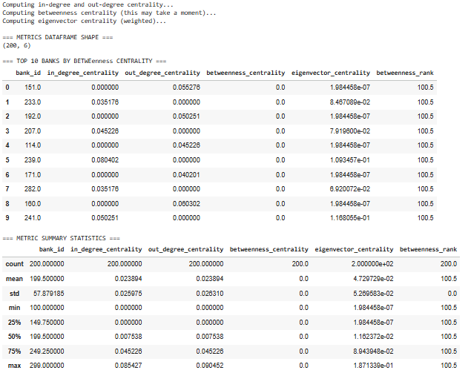
Figure 1: Network metric computation
In-degree and out-degree centrality (Personal network analysis) are used to put institutions in the spotlight of institutions in terms of absorption and transmission capabilities. Betweenness and eigenvector centrality have a smaller difference which shows that there are weak intermediary channels, and the inability of isolated measures (Guilbeault and Centola, 2021).
The composite systemic risk index is compiled of normalised centralities that drive interpretable top-down rankings and selects a small number of controlling banks that extend disproportional connectivity.

5.3 Contagion Simulation and Stress Scenario Results
The contagion simulation weighs the vulnerability of the system provided by stress under hypothetical circumstances by crashing the leading institutions determined as a composite systemic risk index. Loss concerning failure is propagated by rules of proportional loss, and proportional losses are incurred by the failed counterparties. This puts a check on transmission study without causing real-life causality (Covi, Gorpe and Kok, 2021).
Findings reveal the absence of further contagion due to initial failures, transactions that are cascades, constrained to a shock set, referring to resilience.
In the perspective of assessment, it is efficient in testing but based on the assumption of the levels of failure and situations in which it is applied. A major structural understanding, as opposed to a methodological constraint, is cascading failure.
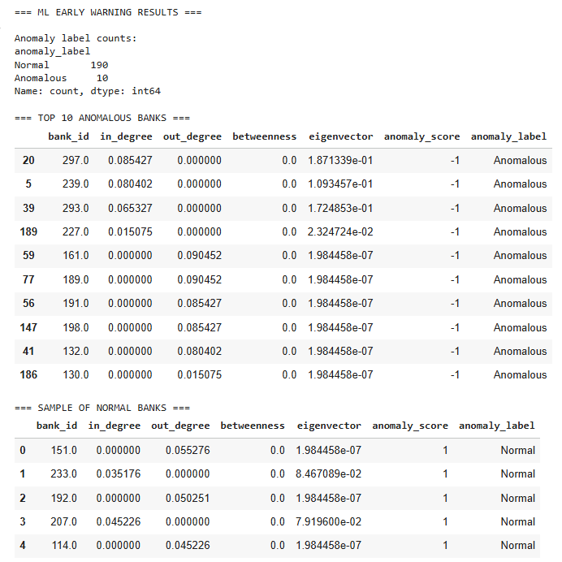
Figure 2: ML EARLY WARNING RESULTS
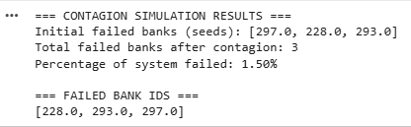
Figure 3: Contagion Simulation

5.4 Visual Analytics and Decision-Support Evaluation
Efficiency in interpretation and analysis based on decision making is considered in visual aspects of the artefact. Network diagrams present clearly the structural locations of institutions, the systemic risk concentrations and overlaps in the scores of network risk and ML anomalies. Systemic risk ranking is an intuitively-impacting plot comparing influential institutions, whereas ML anomaly scatter plots can improve transparency by displaying structural deviation over the larger population.
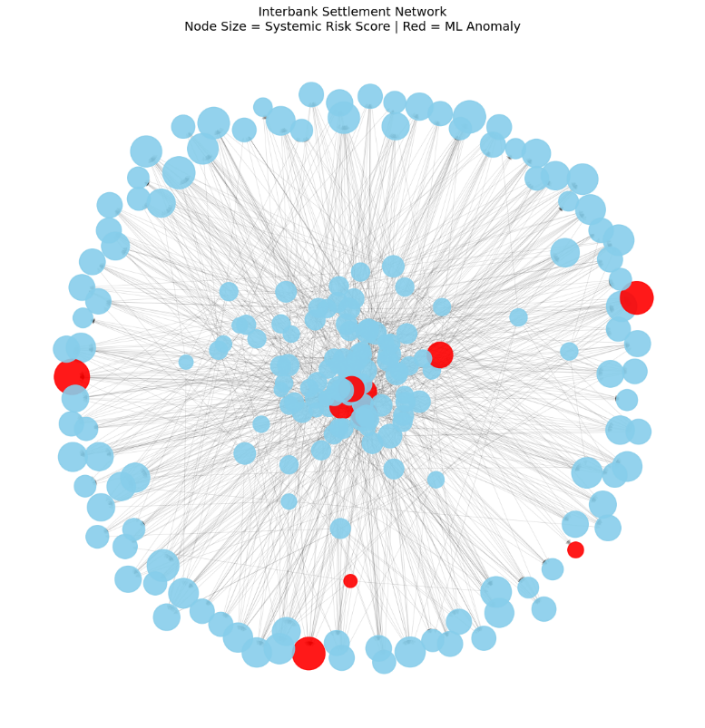
Figure 4: Network visualisation with systemic risk & ML anomalies
These numbers make interpretability agreeable with quantitative results and increase the level of confidence in at-risk institution identification and consistency of the results. In practical terms, they facilitate the exploratory risk monitoring which enhance easy comparisons and detecting concerns without technical know-how.
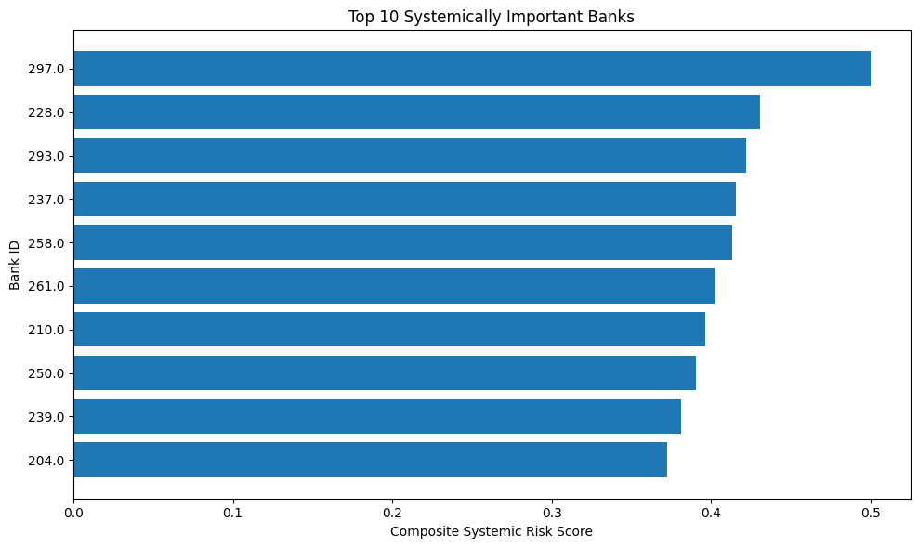
Figure 5: Systemic risk ranking bar chart
Still, images are not dynamic, but rather things that one can observe. The limitations on data and modeling in complicated networks and ML, however, enhance practical interpretability significantly.
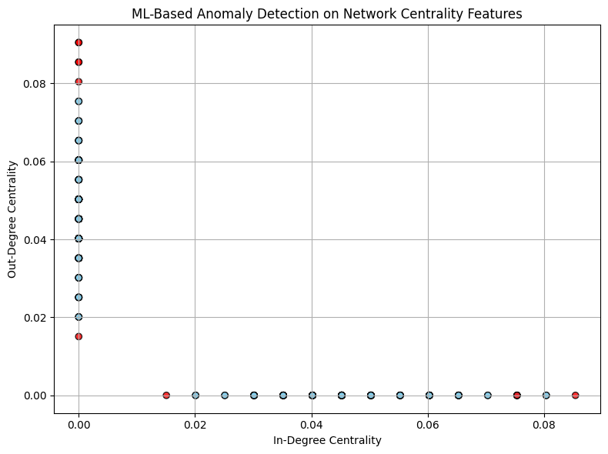
Figure 6: ML anomaly scatter plot

Chapter 6: Discussion and Reflection

6.1 Interpretation of Findings and Link to Literature
This study sheds light on the appearance of systemic risks in interbank settlement networks through the integrated data science, network analysis, and machine learning. Structural concentration of systemic significance has been found whereby a small number of institutions have unequal sway as a consequence of their connections, substantiated by literature on too interconnected to fail, where network position, rather than size, makes them risky (Ellington and Barunik, 2020; Jackson and Pernoud, 2020).
Machine learning is a value addition as an expanding addon of early-warning layer that identifies the existence of anomalous institutions based on network-established risk parameters. On the whole, it supports multi-metric and integrated approaches and outlines the role of contextual network structure in systemic risks.

6.2 Strengths and Limitations of the Approach
The main advantage of this study is that it utilizes a network-based modelling technique that incorporates relational and structural risk factors that conventional institution level risk measurements do not usually address (Sebastián, Acosta-Prado and Ever, 2025). Composite systemic risk index is used to enhance strength by reducing the shortcomings of the single metrics. Also, the inclusion of machine learning as a predictable layer of analysis, but not a black-box predictor, promotes the goals of analytical coherence and encourages early-warning goals. The artefact-based design encourages the transparency and reproducibility of methodology and visual analytics encourages the accessibility and interpretability of analytical outputs of the complex.
Nevertheless, there are a number of restrictions that should be admitted. The analysis is based on simulated proxy data which constrains real-word generalisability. No real time dynamics limits longitudinal risk measurements and results of contagion are fragile to simplification of threshold assumptions. Moreover, the results of simulation are scenario-dependent, and the artefact is created with the purpose of exploration analysis, not deployment.
These limitations do not nullify the results, though, they delineate the limits within which the results are to be interpreted.

6.3 Personal and Technical Reflection
This project gave significant chances of technical and analytical growth, especially in network analysis, machine learning to detect anomalies, simulation modelling, and visual analytics (Srour, Hammoud and Tarabay, 2025). One of the main difficulties was to convert systemic risk theoretical notions into the implementable and interpretable analytical models, and strike the right balance between the complexity and simplicity of the methodology. The project reaffirmed the significance of alignment of methodology in the objectives, data and analysis and emphasized the importance of critical assessment of evaluation as opposed to prediction arguments. On the whole, the work enhanced technical and analytical judgement, which is a strong basis on the basis of future research or professional activity in risk analysis based on data.

Chapter 7: Conclusion and Future Work

7.1 Summary of the Project
This dissertation creates an analytical device to analyze systemic risk in interbank settlement networks, through the use of data science, network analysis and machine learning. It handles the structural and relational features of systemic risk and addresses the constraints of the conventional institution-level measures. The modeling of interbank relationships produces proxy data in the form of directed, weighted networks, which give systemic risk statistics. The tool includes network measurements, contagion/stress modeling, an unsupervised machine learning-based anomaly detection tool and visual analytics to enhance understandability. It gives more importance to analytical and pre-emptive understanding of how interconnectedness and structure influence risk outcomes, as opposed to real-life forecasting of crises (Polat, 2024; Ujjwala Priya Modepalli, 2025).

7.2 Achievement of Objectives
The project attained its objectives completely. Appropriate proxy data was chosen and processed to be analysed on the network. Directions with weights to interbank networks made it possible to compute systemic risk indicators, such as a composite index and identification of important institutions. The vulnerability and stress-resiliency were evaluated using contagion simulations. The network-based machine learning was performed without supervision to identify structurally unusual institutions. Interpretation and decision-making were facilitated by visual analytics and ensured that they were in line with the research questions and objectives (Niu et al., 2021).

7.3 Future Extensions
One way to enhance the future work is to incorporate actual regulatory/supervisory data to increase empirical validity. The introduction of time dynamics would trace the change of risks. Improved early warning can be made with advanced machine learning including graph or time-series models. The tool is also possible to adapt to policy/regulatory stress testing in supervisory environments.

References
-Fredrickson, G. (2013) The Equilibrium Theory of Inhomogeneous Polymers (International Series of Monographs on Physics). Oxford University Press [online]., p. 35–41. [Accessed 26 June 2025].
-Fishman and Parker, M.J., J.A. (2015) ‘Valuation, Adverse Selection, and Market Collapses’. Review of Financial Studies 28(9) [online]., p. 2575–2607. [Accessed 25 June 2025].
-Englund, P. (1999) ‘The Swedish Banking Crisis: Roots and Consequences’. Oxford Review of Economic Policy 15(3) [online]., p. 80–97. [Accessed 26 June 2025].
-Felsenfeld, C. (1990) ‘Savings and Loan Crisis, The’. Fordham L. Rev. S7 [online]., p. 59. [Accessed 26 June 2025].
-Hakwa, B. (2011) ‘Measuring the Marginal Systemic Risk Contribution Using Copula’. Available at Ssrn 1934894 [online]., p. 93. [Accessed 29 June 2025].
-Haldane, A.G.E.T.A.L. (2009) ‘Rethinking the Financial Network’. Speech Delivered at the Financial Student Association, Amsterdam, [online]., p. 1–26. [Accessed 30 June 2025].
-Friedman and Schwartz, M., A.J. (2008) A Monetary History of the United States. Princeton University Press [online]., p. 59. [Accessed 30 June 2025].
-Freeman, L.C. (1977) ‘A Set of Measures of Centrality Based on Betweenness’. Journal of Sociometry [online]., p. 35–41. [Accessed 25 June 2025].
-Gorton and Metrick, G.A. (2012) Securitized Banking and the Run on Repo. Journal of Financial Economics [online]., pp. 425-451. [Accessed 02 July 2025].
-Hardach, G. (1996) Weltmarktorientierung Und Relative Stagnation, Vol 27. Duncker Und Humblot [online]., p. 1–26. [Accessed 02 July 2025].
-Haubrich, J.G. (1988) ‘Optimal Financial Structure in Exchange Economies. International Economic Review [online]., p. 217–235. [Accessed 02 July 2025].
-Hirshleifer and Hong Teoh, D.S. (2003) ‘Herd Behaviour and Cascading in Capital Markets: A Review and Synthesis’. European Financial Management 9(1) [online]., pp. 25-66. [Accessed 02 July 2025].

Appendix

I have provided you the link for my GitHub Repository which contains all the files needed for my final year project.
https://github.com/Lakshayr96/LAKSHAY-FINAL-YEAR-PROJECT.

